Innova Solution Test Project:

***Web:***

1. <https://localhost:44391/user/signup>

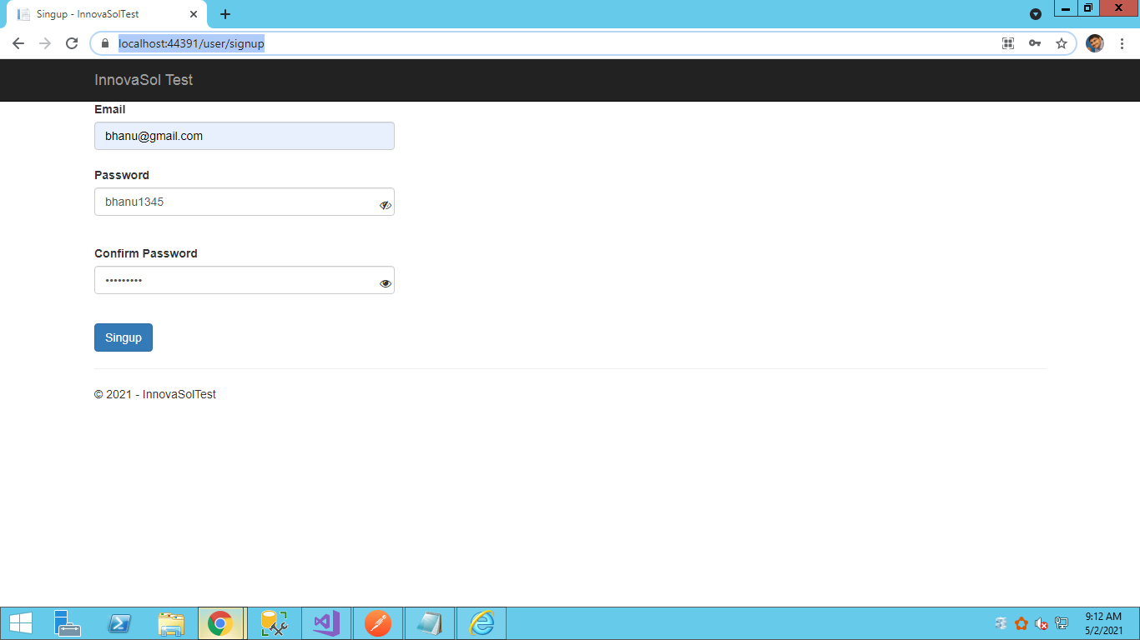

1. Enter email id and password and confirm password
2. Click on eye icon to show /hide password
3. Click on Signup button validate email and password and confirm password
4. After suceessful validation, send api request to register user in db and send automatic email to user email id
5. On Successful user creation send an email to user to verfiy the account with verification code

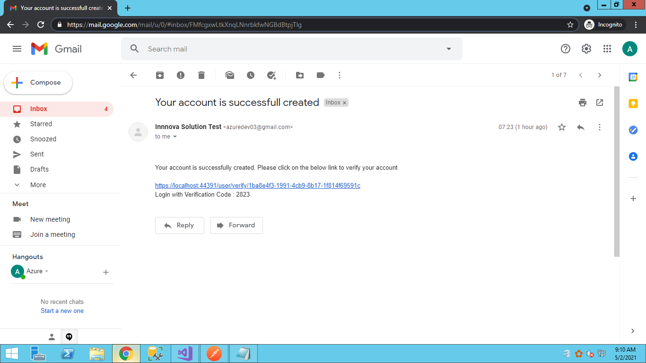

1. On click on Verify account link
2. Verify the user email and activation code and redirect to signin screen
3. Signin -> <https://localhost:44391/user/signin>
   1. Enter email id
   2. Enter password
   3. Enter verification code received in gmail
   4. On click Signin, send api call to verify the code and gmail.
   5. After verification user will navigate to Update screen page
4. Update -> <https://localhost:44391/user/update/bhanu@gmail.com>

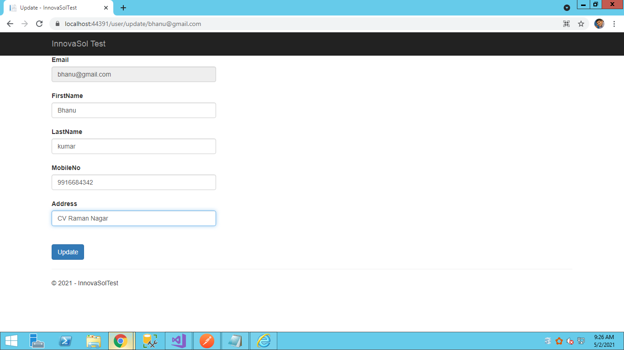

* 1. Enter First name and Last Name
  2. Enter Mobile no and Address
  3. Click on Update -> will call backend api to update user details

***Backend API:***

1. Signup
2. <https://localhost:44300/api/user/signup>

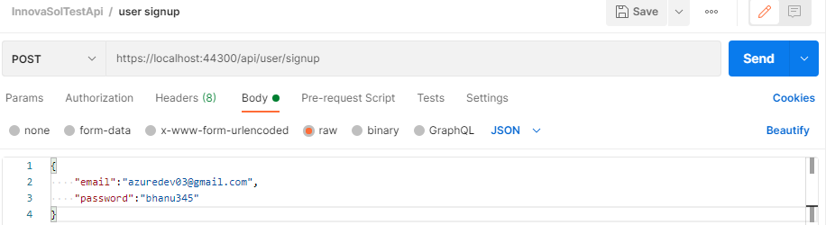

1. SignIn

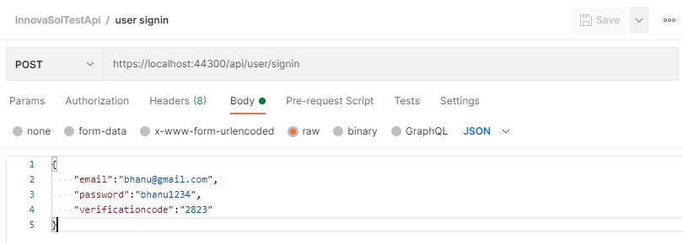

1. Verify User
2. <https://localhost:44300/api/user/verify/1ba8e4f3-1991-4cb9-8b17-1f814f69591c>
3. Verify the activation code
4. Update User
5. <https://localhost:44300/api/user/update>

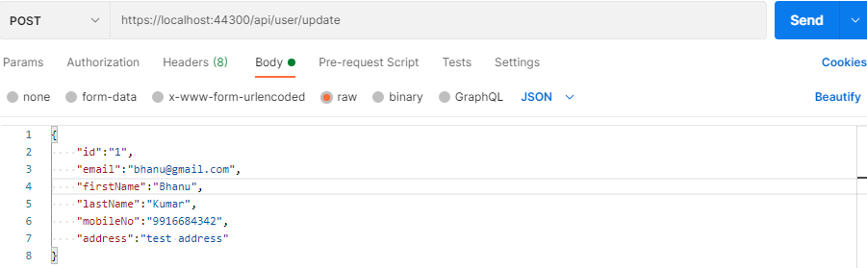

**Solution Structure:**

